Analysis on Impact of COVID -19 on Employment in USA

An analysis using GIS Technology

Archit Jain†  
 School of Information  
 Rochester Institute of Technology  
 Rochester New York United States aj4907@rit.edu

ABSTRACT

Employment rates in United States fall drastically during first quarter of 2020. As the global pandemic Covid-19 is on the rise the unemployment in United States continue to rise. The Lockdown in states caused the disruptions and many people found themselves out the job and even the small business are impacted. With the use of Geographical Information Systems and technology a smarter approach can be made to tackle the Corona Virus pandemic. A smarter and dynamic policies can be made depending upon the impact area.

This paper aims to analyze the issues and develop maps which can be used to spread awareness, create more specific policies. The resultant maps can be used to interpret the data better and visualize the problem of unemployment at the state level in the united states. A deeper analysis of generated map revealed spread of the Virus is directly related to the layoffs. The small businesses which for 50% of the GDP and employment also suffers due to Covid-19. There are few outlier states which have performed better than others to both Covid-19 and employment. Also, there are few states which have suffered high unemployment post pandemic with very few actual reported cases in the state.

This paper hopes Policy makers can develop a more focused for policies for the impacted group and Analyst can better plan strategic economic rebound.

CCS CONCEPTS

• Geographical Information systems modelling

KEYWORDS

Covid-19, Unemployment, Spatial data small Businesses, Economy, GIS, ArcGIS

1 Introduction

In the late 2019 the novel coronavirus named as SARS-CoV-2 encountered humans in Wuhan china. And as humans didn’t have any impunity to new virus it became a global pandemic. The world health organization recognized the covid-19 disease as a global pandemic on March 11, 2020 with 118k cases in over 114 countries[11]. As of date of writing this report on October 6th, 2020 there are over 35 million cases, including 1 million deaths worldwide [12].

As of result of global pandemic on rise, several countries opted to enforce quarantine to slow down the spread of the virus and social distancing became a norm. In the United States due to social distancing several small businesses needed to be closed. As fear and hysteria among population increases the investment, trading went down.

The downward spiral of economy started without any actual underlying problem with finance market. As a result, many of work force found themselves out of their jobs as the layoff continued due to low demand and precaution to a predicted recession[6].

2 Problem Domain

Due to Covid-19 Pandemic the whole world has gone into the quarantine and business and economy are at all-time low. There are over 14 million people in united states alone who have their employment impacted by the Covid-19 in a very short amount of time. The unemployment rate in united states during the month of February 2020 was 3.8% which was lowest around 70 years and has shot up to 16.4% in the month of April and is now at 11.4% during the month of August 2020[1].

As the pandemic has disrupted the lives, all the sectors are facing

Economic slowdown. With some are more impacted than the others. The small business which are 50% of GDP are one of the most impacted sectors[3]. This resulted in demand shock which dealt a blow to the consumer services thus reducing the economy’s capacity to produce goods and services. Hence, triggering layoffs and unemployment.

Unfortunately, there is no clear mapping and modelling done at the state level which can showcase the unemployment geographically. Thus the 3 main challenges exiting with modelling and mapping unemployment rate as following.

Firstly, there is need to map the unemployment to the map and modelling such that policy makers can better understand the problem at the regional level.

Secondly the current information present on unemployment are in numeric form and only few maps exist which can be geographically used to understand and model the problem.

Lastly, there is no direct modelling present mapping the impacted small businesses data present to Covid-19 at the state level in united states. Hence, a direct map which represents the impact on small business due to covid-19 can help policy maker to develop more focused policies. Also, small business can plan strategies the reopening of their businesses.

3 Goals and Objectives

3.1 Goals

*3.1.1* The goal is to gather data, model, present and analyze impact of covid-19 on unemployment rate data in geographically for the united states.

*3.1.2* Generate map and Analyze the trends to creating awareness among small business and policy makers. Thus, create confidence to reopen business in the areas which are not impacted by the coronavirus.

The objectives for these goals are as follows:

3.2 Objectives

1. Gather the state wise data from CDC for Covid-19 cases.
2. Gather the data for unemployment from US department of Labor.
3. Join the data of the Covid-19 and unemployment rate.
4. Map the areas of Covid-19 and unemployment rate statewide over the US states shape file.
5. Map US states with high risk small businesses.
6. Map the US states with Covid-19 and high-risk small businesses to showcase the impact.
7. Analyze and draw trends from the produced map.
8. Provide graphical evidence to control the spread of virus to improve the Jobs in labor market.

4 Literature Review

Due There are mainly three literature surveys which were followed. Michael Dalton explores the impact of the Covid-19 on employment of different sectors of the industry. Micron data has been collected from the US Bureau of Labor Statistics. The data has been collected through surveys. Particularly from Current Employment statistics survey and the Current Population survey. The paper uses the longitudinal effect of both the surveys to measure and calculate impact on the employment in business sector[2].

It is found the industry which were less likely to operate remotely were heavily impacted. Also, it is clearly noted the spread of covid-19 virus is directly proportional to temporally job loss. The greatest loss of the employment is in the counties with highest reported Corona virus cases. The effects are varied across industries as it is found to be greatest impacted industries are the Leisure/ Hospitality businesses. Followed by the transportation , construction and the manufacturing industries. The software and the internet business are the least impacted. Finance and insurance businesses are also remote friend and are less impacted by this[2].

The second paper authored by Alexander provides the insight into economic impact of covid-19 on the small businesses. The survey used the data from 5,800 responses to gather the data. The paper also considers the sensitive nature of the small businesses to react to the covid-19 lockdown situation. The paper acknowledges the impact can be felt within weeks after the disruption caused by the Covid-19. The results show both short term and long-term impact of the corona virus on these small businesses . It also provides the evidence on the business expectations to reopen the and their perception on the long term[3].

It noted that risk of closure of the businesses is indirectly linked to the expected length of the novel corona virus crisis. The small businesses employ about 50% of workers in America. Addressing employment problem will need to also take care of small business which employ such large masses.43% of the retail business are closed. 38% of business viewed unlikely as they will reopen their business by the end of 2020. An awareness drive with help this project may help the business not impacted by Covid-19 anymore may feel confident in reopening their business. Mapping the exposed industries which are being impacted may help policy makers aid these small businesses more efficiently[3].

In the third paper Author, George analyses the adverse impact of the covid19 labor market shock on the immigrant population. The paper is written at the national bureau of the economic research Cambridge, MA, the author uses the data from the CPS monthly files to map the employment decline was specifically high for the immigrant workers. The covid-19 impact is varied for the immigrant population vs non-immigrant population. The paper suggested that Covid-19 has disrupted the life of the population. By April 2020 immigrant population ad lower employment rates than the native population. It is speculated that the part of loss in employment might be due to immigrants were less likely to work in jobs that was remotely available and hence suffered disperse employment. As lockdown caused work from home and required skills for the remote jobs blue collared jobs were more impacted as compared to white collared jobs[4].

5 Methodology

5.1 Phase I Gather Data

The first step is to gather the relevant data in order to map and start modelling. The data is collected from the Center for Disease Control and Prevention (CDC) of the United States for the Covid-19 confirmed cases , new cases and the overall deaths [7].

The data for unemployment is challenging part. As their various agencies uses the data from surveys as it is too early to have confirmed data with little to no errors. However, the data collected from the Department of Labor Statistics is most reliable data that could have been used. Since US bureau of Labor uses surveys to collect the data the accuracy of the data is somewhat questionable but is good enough for the scope of this project.

The next set of data on small house holds are collected from Wallethub.com. They use the surveys again to obtain their data on small households and Businesses . The data collected shows rating on how much risk small businesses are based on the states.

All the data in the tables were cleaned for necessary joins. The extra columns were removed. The removal of null values and conversion of the files obtained to a csv file was done. The ranks column was created using python3 on ArcGIS. Similarly, the other fields were reformatted to double using phthon3 on ArcGIS.

5.2 Phase 2: Modelling

The Software ArcGIS is chosen for retendering and modelling of the Map. With each state now clearly defined and is compatible with our software.

As the map modeling is focused on US states, a base layer projection is created using the Shape file from the USA census.gov website. The cartographic boundary file is used here as they are the simplified version of the key focus of interest. These shapefiles are specifically designed for the small-scale thematic mappings and modeling and hence perfect for scope of this project. The Shape file forms as the base layer of the map.

The shape file is then joined by the corona virus cases on the states. The use of Graduated Colors is symbology scheme is used as a base layer to showcase the coronavirus spread per state. A class of 5 colors with naturals breaks are used.

The unemployment rate per state is created by joined on the new shapefile of the states. The graduated symbology feature is used to denote the high employment rate and is contrasted on corona virus layer to draw the connections and trends.

The Second map created by joining the states shape file on the high-risk small business layers by states. And use of the graduated colors are used here to showcase the high-risk business in different states.

The third and the last map is created by using the corona virus base layer the small business impacted layer and contrasting them over each other to denote resemblance between the states which are highest impacted by Covid-19 and states where risk is highest for small businesses.

6 Dataset

1. The datasets used were for Covid-19 data was from Center for Disease Control and Prevention(CDC) United States.
2. The data for the unemployment is taken from the United States Local Area Unemployment Statistics.
3. The Shape File for states in USA is taken from the Census.gov for the credible source.
4. The Data for the Risk per state for the small business are taken form the Wallet hub survey site.

The Snapshots of the data from tables are as follows:

|  |  |  |
| --- | --- | --- |
| **State** | **Rate(%)** | **Rank** |
| Alabama | 5.6 | 7 |
| Alaska | 7.4 | 26 |
| Arizona | 5.9 | 11 |

**Table 1: Snapshot of Unemployment table with ranking**

|  |  |  |
| --- | --- | --- |
| **State/Territory** | **Total Cases** | **Total Deaths** |
| Alaska | 8405 | 58 |
| Alabama | 159169 | 2558 |
| Arkansas | 87013 | 1425 |

**Table 2: Snapshot of the Covid-19 Table after cleaning.**

|  |  |  |
| --- | --- | --- |
| **State** | **Risk Score** | **Rank** |
| Alabama | 48.08 | 27 |
| Alaska | 46.83 | 32 |
| Arizona | 56.96 | 7 |

**Table 3: Snapshot of the Small Businesses Risk Table.**

7 Results

The figure 1 contains the mapping of the unemployment with the red dots against the Corona Virus cases. The States with highest number of Covid-19 Cases are in dark blue. Whereas, states with less Covid-19 cases are marked in light color. The red dots represent high unemployment rate. From the figure the States of New York and California are facing high unemployment directly due to impact of Covid-19.

However, states like New Mexico and Nevada are facing high job losses without any underlying high number of Covid-19 Cases. Hence Such maps can be used to spread awareness and create confidence to help the States where there is low risk of Corona Virus but is getting impacted due to fear and hysteria.

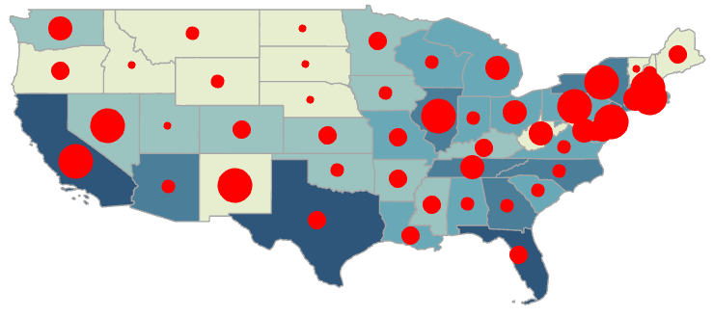

Figure 1: Covid-19 Cases Vs Unemployment

The Second figures clearly highlight the areas where the most impacted of Corona Virus can be seen on Small businesses. The Dark red colors represent highest shutdown of small business in united states. States like Nevada, South Dakota , Mississippi and South Carolina are impacted the most. However, these states are not the Top impacted states due to corona virus.

Thus, it can be concluded that a more dynamic policies on lockdown can help these states exponentially. As the small business make up to 50% of employment in the United States of America is should be top priority of the US government to help such business from keeping the downward spiral of the Economy.

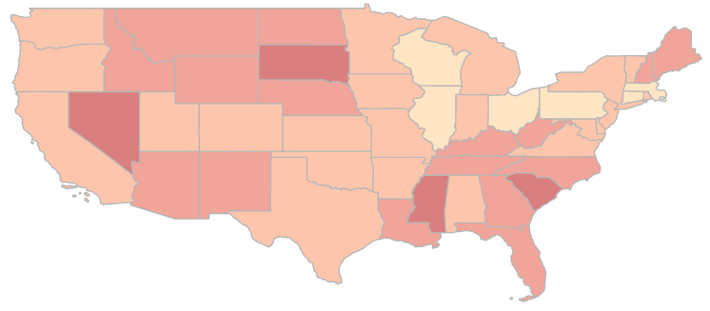

Figure 2: Impact on the Small Businesses by states due to Covid-19

Figure 3 is a direct comparison of the small business and the Covid-19 impacted states. The original plan of the heat map was not possible due to technical issues and time limitations. Hence the focus shifted to have the two maps contrast over each other with graduated color scheme for the better understanding.

The parts which are the darkest are ones which are both impacted by the Covid-19 and highest impact on small businesses. However, the states which are dark red are the ones which are impacted due mere lockdown and fear amongst the local population and have some room for improvement. The States (Wisconsin , Ohio, Pennsylvania and Illinois) which are green in color are the safest both in terms of job opportunities and in term of Corona virus spread. The other states can use their model on policy to combat the current crisis with better results.

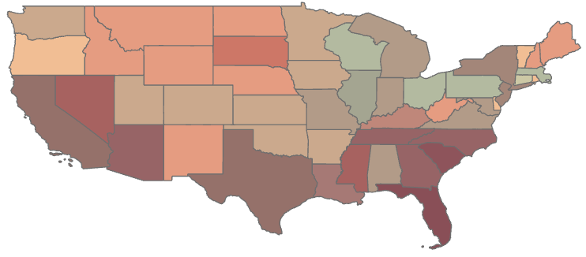

Figure 3: Contrast of Covid-19 Cases by states with High Risk Businesses by States

8 Summary

To summaries with the ongoing pandemic the unemployment rate is high and a threat to US economy. To combat the crisis Geographical Information technology software and concepts can help to mitigate and meet these problems head on. With developed maps clear trends can be seen and a more dynamic approach can be taken for the lockdowns and social distancing with necessary precautions in place.

9 Conclusion

Thus, it clear that Covid-19 has direct impact on the employment in the United States. These impacts are varied across states and have different trends. As the spread of the virus increase the layoff also increases. The employment rate has reduced from the months of Aprils and March however are still high. There is certain variation in response of certain states to Covid-19. As the few states are present at outlier with low corona virus spread and high layoffs. States like Nevada and New Mexico are such outliers. Better policies can be developed so that these impacts can be reduced.

Also, the states which have the best response to both Covid-19 and employment are Wisconsin , Ohio, Pennsylvania and Illinois. These states can be used as models to adopt policies.

The Small Businesses are important aspect of US economy employing about 50% of US population and contributing half of US’s GDP. With the help of GIS technology these businesses can benefit and become more aware and start to reopen the businesses.

Thus, with this project we have identified the areas where the economy is most hit, and the virus is not prevalent anymore.

Policy makers can develop a more focused for policies for the impacted group. Analyst can plan strategic economic rebound using such information and technology.

10 Future Work

A real time dashboard which can show the most recent information regarding the Covid-19 spread and unemployment can help business to decide when to reopen. The policy maker can check the data in real time to enforce lockdown or reduce restrictions.

ACKNOWLEDGMENTS

I would like to thank Professor Brian Tomaszewski for inspiring and giving the opportunity to develop and present this report.

REFERENCES

[1] <https://www.pewresearch.org/fact-tank/2020/06/11/unemployment-rose-higher-in-three-months-of-covid-19-than-it-did-in-two-years-of-the-great-recession/>

[2] Michael Dalton, "Geographic impact of COVID-19 in BLS surveys by industry," Monthly Labor Review, U.S. Bureau of Labor Statistics, August 2020, <https://doi.org/10.21916/mlr.2020.17>.

[3] “The Impact of COVID-19 on Small Business Outcomes and Expectations | PNAS,” accessed September 25, 2020, [https://www.pnas.org/content/](https://www.pnas.org/content/117/30/17656)

[4] George Borjas and Hugh Cassidy, “The Adverse Effect of the COVID-19 Labor Market Shock on Immigrant Employment” (Cambridge, MA: National Bureau of Economic Research, May 2020), <https://doi.org/10.3386/w27243117/30/17656>.

[5] <https://www.bls.gov/covid19/effects-of-covid-19-pandemic-on-employment-and-unemployment-statistics.htm>

[6] <https://www.ncsl.org/research/labor-and-employment/covid-19-impact-on-employment-and-labor.aspx>

[7] <https://covid.cdc.gov/covid-data-tracker/index.html#cases_totalcases>

[8] <https://www.bls.gov/web/laus/laumstrk.htm>

[9] <https://www.arcgis.com/apps/opsdashboard/index.html>

[10] <https://coronavirus-resources.esri.com/datasets/3beafacbb8204e6e85e039a0d96b4fc9>

[11] <https://www.who.int/>

[12] <https://covid19.who.int/>

[13] https://wallethub.com/edu/states-with-the-most-affected-small-businesses-due-to-coronavirus/72977/

Conference Name:ACM Woodstock conference

Conference Short Name:WOODSTOCK’18

Conference Location:El Paso, Texas USA

ISBN:978-1-4503-0000-0/18/06

Year:2018

Date:June

Copyright Year:2018

Copyright Statement:rightsretained

DOI:10.1145/1234567890

RRH: F. Surname et al.

Price:$15.00